Programme Code: DT9231
Module Code: DATA MATH 9102
CRN 32040

TECHNOLOGICAL UNIVERSITY DUBLIN
KEVIN STREET CAMPUS

_____________

Postgraduate Certificate in Data Science

Year 1
______________

SEMESTER 1 EXAMINATIONS 2019/20
______________

Probability and Statistical Inference

Dr. Bojan Božić
Dr. Deirdre Lillis
Dr. Ignacio Castiñeiras

Two Hours

Instructions to candidates.

Answer question 1 and one other question.

All questions carry equal marks.

1. | (a) | What is a confounding variable?  (2 marks)
 | (b) | If my null hypothesis is ‘Dutch people do not differ from English people in height’, what is my alternative hypothesis?  (3 marks)
 | (c) | If the scores on a test have a mean of 26 and a standard deviation of 4, what is the z‐ for a score of 18?  (3 marks)
 | (d) | What does the probability in p-value mean?  (2 marks)
 | (e) | What is a type I error?  (2 marks)
 | (f) | Provide the equation that demonstrates the relationship between the sum of squared errors (SS), the sample size (n) and the variance (s2)?  (3 marks)
 | (g) | Based on the following chart, what was the interquartile range of sperm count for ‘No soya meals’ (approximately). Don’t forget to explain the process!  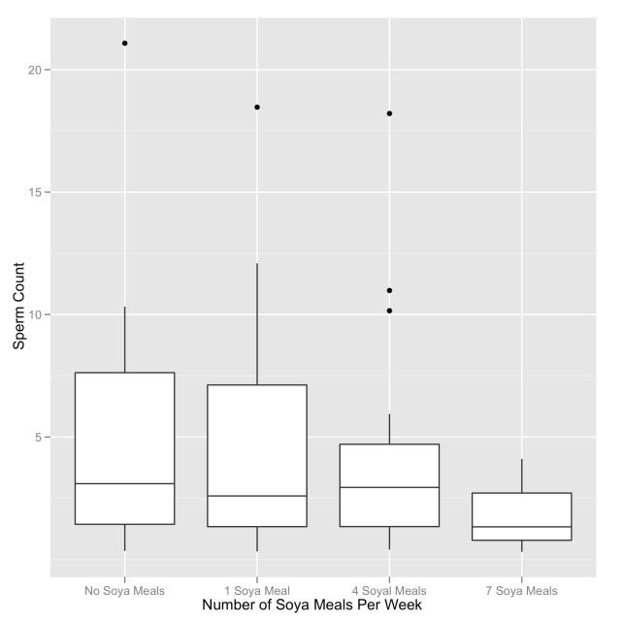  (3 marks)
 | (h) | Which measure of central tendency is least affected by outliers and why?  (2 marks)
 | (i) | The assumption of homogeneity of variance is met when?  (2 marks)
 | (j) | How much variance has been explained by a correlation of .9?  (2 marks)
 | (k) | The relationship between two variables controlling for the effect that a third variable has on one of those variables can be expressed using a:  (3 marks)
 | (l) | What is R2?  (3 marks)
 | (m) | For which regression assumption does the Durbin–Watson statistic test? Why is this important?  (3 marks)
 | (n) | A psychologist was interested in whether there was a gender difference in the use of email. She hypothesized that because women are generally better communicators than men, they would spend longer using email than their male counterparts. To test this hypothesis, the researcher sat by the email computers in her research methods laboratory and when someone started using email, she noted whether they were male or female and then timed how long they spent using email (in minutes). What should she report? Consider the results provided below. What did you use to test the findings?  Welch Two Sample t-test  data: Time Using Email  t = -1.895, df = 7.177, p-value (two-tailed) = 0.099  alternative hypothesis: true difference in means is not equal to 0  95 percent confidence interval:  -60.52295 6.52295  (6 marks)
 | (o) | What is an independent t‐test used for? (3 marks)
 | (p) | A researcher measured the same group of people’s physiological reactions while watching horror films and compared them to when watching erotic films. The resulting data were normally distributed. What test should be used to analyse the data and why?  (4 marks)
 | (q) | A researcher measured people’s physiological reactions while watching horror films and compared them to when watching erotic films and a documentary about wildlife. Different people viewed each type of film. The resulting data were normally distributed and the variances across groups were similar. What test should be used to analyse the data and why?  (4 marks)

2. | (a) | A psychologist was looking at the effects of an intervention on depression levels. Three groups were used: waiting list control, treatment and post treatment (a group who had had the treatment 6 months before). The change in depression levels over the time of the treatment was recorded (although bear in mind only the treatment group actually got any treatment during this time). The R output is below. Based on this output, what should the researcher conclude?  Levene's Test for Homogeneity of Variance (center = "median")  Df F value Pr(>F)  group 2 4.246 0.020  45  Df Sum Sq Mean Sq F value Pr(>F)  group 2 529.437 264.719 5.110 .010  Residuals 45 2331.135 51.803  One-way analysis of means (not assuming equal variances)  data: tumour and usage  F = 4.345, num df = 2.00, denom df = 26.436, p-value = .023  (5 marks)
 | (b) | What kind of trend does the following graph show?  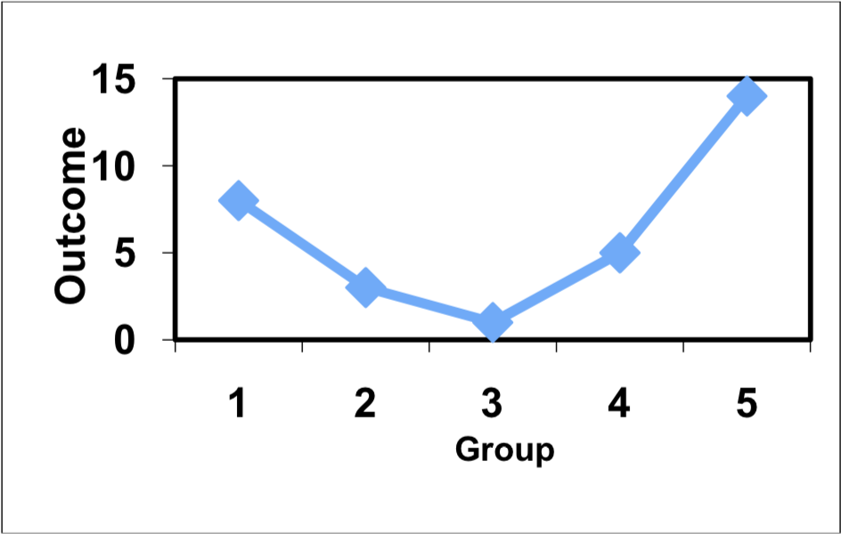 (2 marks)
 | (c) | The student welfare office was interested in trying to enhance students’ exam performance by investigating the effects of various interventions. They took five groups of students before their Research Methods II (RMII) exams and gave them one of five interventions: a control group just sat in a room contemplating the task ahead; the second group had a yoga class to relax them; the third was told they would get monetary rewards contingent upon the grade they received in the exam; the fourth was given beta‐blockers to calm their nerves; and the fifth was encouraged to sit around winding each other up about how much revision they had/hadn’t done (a bit like what usually happens). The final percentage obtained in the exam was the dependent variable. The student welfare office made four predictions: (1) all interventions should be different than the control; (2) yoga, bribery and beta‐blockers should lead to higher exam scores than panic; (3) yoga and bribery should have different effects than the beta‐blocker drugs; and (4) yoga and bribery should also differ. Which of the following planned contrasts (with the appropriate group codings) are correct to test these hypotheses?  (continues on next page)  Contrasts 1:  Contrasts 2:  Contrasts 3:  Contrasts 4:  (10 marks)
   | Contrast 1 | Contrast 2 | Contrast 3 | Contrast 4
  Control | –4 | 0 | 0 | 3
  Yoga | 0 | 1 | 1 | –1
  Beta-blockers | 0 | 1 | –2 | 0
  Bribes | 0 | 1 | 1 | 1
  You’re all going to fail | 0 | –3 | 0 | 0
   | Contrast 1 | Contrast 2 | Contrast 3 | Contrast 4
  Control | –1 | 0 | 0 | 0
  Yoga | 1 | 1 | 1 | –1
  Beta-blockers | 1 | 1 | –1 | 0
  Bribes | 1 | 1 | 1 | 1
  You’re all going to fail | 1 | –1 | 0 | 0
   | Contrast 1 | Contrast 2 | Contrast 3 | Contrast 4
  Control | –4 | 0 | 0 | 0
  Yoga | 1 | 1 | 1 | –1
  Beta-blockers | 1 | 1 | –2 | 0
  Bribes | 1 | 1 | 1 | 1
  You’re all going to fail | 1 | –3 | 0 | 0
   | Contrast 1 | Contrast 2 | Contrast 3 | Contrast 4
  Control | –4 | 1 | 1 | 1
  Yoga | 1 | 1 | 1 | -4
  Beta-blockers | 1 | 1 | -4 | 1
  Bribes | 1 | 1 | 1 | 1
  You’re all going to fail | 1 | -4 | 1 | 1
 | (d) | A music teacher had noticed that some students went to pieces during exams. He wanted to test whether this performance anxiety was different for people playing different instruments. He took groups of guitarists, drummers and pianists (variable = Instru) and measured their anxiety (variable = Anxiety) during the exam. He also noted the grade of exam they were taking (in the UK, musical instrument exams are known as ‘grades’ and range from 1 to 8). He wanted to see whether the type of instrument played affected performance anxiety when controlling for the grade of the exam. What analysis should he use? (3 marks)
 | (e) | The next part of the R output for the example in the previous question is given below. Write a statement that best reflects what the effect of INSTRU in the table tells us? (continues on next page)  Response: ANXIETY  Sum Sq Df F value Pr(>F)  (Intercept) 32903.788 1 197.594 .000 ***  GRADE 907.833 1 5.452 .023 *  INSTRU 6351.708 2 19.072 .000 ***  Residuals 9325.228 56  (10 marks)
 | (f) | A psychologist was interested in the effects of different fear information in children’s beliefs about an animal. Three groups of children were shown a picture of an animal that they had never seen before (a quoll). Then one group was told a negative story (in which the quoll is described as a vicious, disease‐ridden, bundle of nastiness that eats children’s brains), one group a positive story (in which the quoll is described as a harmless, docile creature that likes nothing more than to be stroked), and a final group weren’t told a story at all. After the story children rated how scared they would be if they met a quoll, on a scale ranging from 1 (not at all scared) to 5 (very scared indeed). To control for the natural anxiousness of each child, a questionnaire measure of trait anxiety was given to the children and used in the analysis. The (edited) R output is below. The next two questions relate to this output.  Response: Fear of Animal  Sum Sq Df F value Pr(>F)  (Intercept). 96.249 1 109.141 .000 ***  Natural Fear Level 4.924 1 5.579 .022*  Type of Information. 13.567 2 7.685. .001 **  Residuals. 49.426 56  : Type of Information  : Positive  mean SE.mean  2.594 .219  ------------------------  : Negative  mean SE.mean  3.658 .211  ------------------------  : None  mean SE.mean  2.697 .215  -------------------------  Simultaneous Confidence Intervals  Multiple Comparisons of Means: Tukey Contrasts  Fit: aov(formula = libido ~ partnerLibido + dose, data = viagraData)  Quantile = 2.4856  95% family-wise confidence level  Linear Hypotheses:  Estimate lwr upr  Positive - None == 0 -0.103 -0.880 .675  Negative - None == 0 0.961 0.225 1.697  Negative - Positive == 0 1.064 0.306 1.823  (continues on next page)  - What analysis has been used?  - What does the effect of Natural Fear Level in the table tell us?  (20 marks)

3. | (a) | A nutritionist conducted an experiment on memory for dreams. She wanted to test whether it really was true that eating cheese before going to bed made you have bad dreams. Over three nights, the nutritionist fed people different foods before bed. One night they had nothing to eat, a second night they had a big plate of cheese, and the third night they had another dairy product, milk, before bed. All people were given all foods at some point over the three nights. The nutritionist measured heart rate during dreams as an index of distress. How should these data be analysed? Explain your choice!  (5 marks)
 | (b) | An experiment was conducted to see how people with eating disorders differ in their need to exert control in different domains. Participants were classified as not having an eating disorder (control), as having anorexia nervosa (anorexic), or as having bulimia nervosa (bulimia). Each participant underwent an experiment that indicated how much they felt the need to exert control in three domains: eating, friendships and the physical world (this final category was a control domain in which the need to have control over things like gravity or the weather was assessed). So all participants gave three responses in the form of a mean reaction time; a low reaction time meant that the person did feel the need to exert control in that domain. The variables have been labelled as group (control, anorexic, or bulimic) and domain (food, friends or physics). The R output from an analysis is shown below and the next two questions relate to this output.  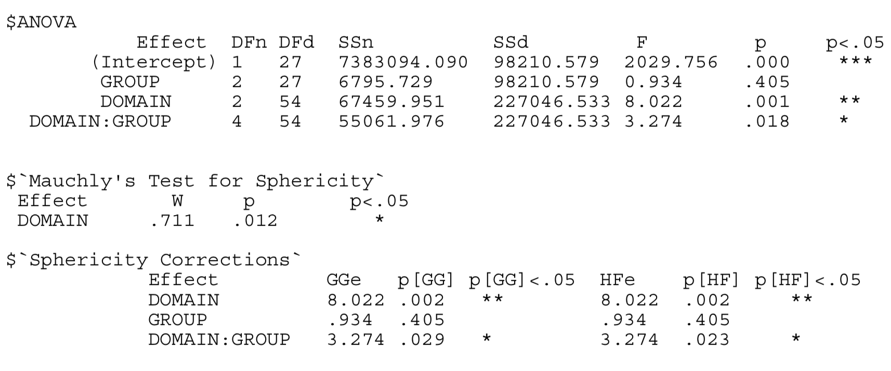  - What analysis has been conducted?  - What can we conclude about the main effect of the group variable?  (15 marks)
 | (c) | A psychologist was interested in whether there was a gender difference in the use of email. She hypothesized that because women are generally better communicators than men, they would spend longer using email than their male counterparts. To test this hypothesis, the researcher sat by the email computers in her research methods laboratory and when someone started (continues on next page)  using email, she noted whether they were male or female and then timed how long they spent using email (in minutes). How should she analyse the differences in males and females?  (5 marks)
 | (d) | 933 people were asked what their favourite type of TV programme was: news, documentary, soap or sports. They could only choose one answer. As such, the researcher had the number of people who chose each category of programme. How should she analyse these data?  (5 marks)
 | (e) | What does the R output show?  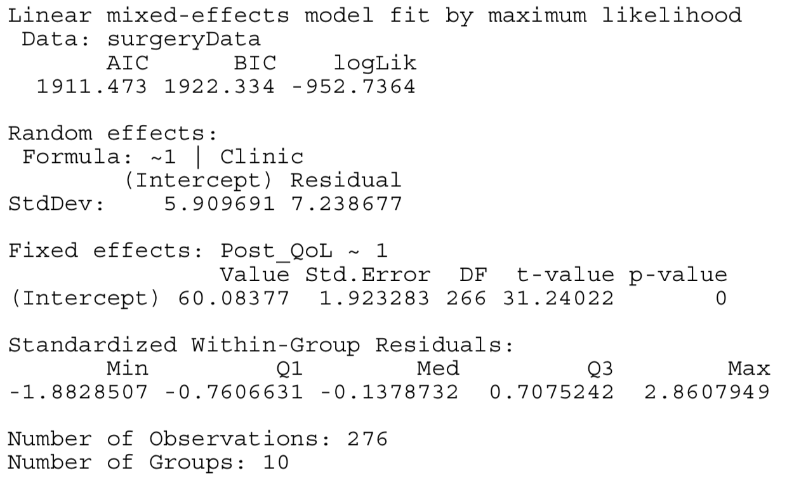  (10 marks)
 | (f) | A researcher had data collected at several schools measuring children’s emotional intelligence, age, and academic performance. Which analysis should he perform to test whether academic performance is predicted by emotional intelligence when controlling for age?  (5 marks)
 | (g) | In the context of multilevel models what do we mean by a fixed regression coefficient?  (5 marks)

